**Supplementary Information**

Global high-frequency *in-situ* temperature data shed light on unexplained macroecological patterns

Darren L.C.Y Li Shing Hiung1, Jasmin M. Schuster1, Murray I. Duncan2, Nicholas L. Payne3, Brian Helmuth4, Jackson Wing Four Chu5, Amanda E. Bates6

1Department of Ocean Sciences, Memorial University of Newfoundland, 0 Marine Lab Road, St. John's, NL A1C 5S7, Canada

2Geological Sciences and Hopkins Marine Station, Stanford University, Stanford, CA, USA

3Trinity College Dublin; Dublin, Ireland

4Northeastern University, 360 Huntington Ave, Boston, MA 02115, United States

5Pacific Science Enterprise Centre, Fisheries and Oceans Canada, 4160 Marine Drive, West Vancouver, BC V7V 1N6, Canada

6Biology Department, University of Victoria, 3800 Finnerty Road, Victoria, BC V8P 5C2, Canada

Table of Contents

Supplementary Figures 3

Supplementary Fig. 1: Differences in the temperature range (a-d) and range of biological rates (e-h) in temperate (blue), subtropical (yellow) and tropical (red) regions, computed at 5 temporal windows: daily, weekly, biweekly, monthly, and annual. The results shown here used a subset of the data in Figure 3 of the main paper, as a sensitivity test to check the robustness of our results. For each temporal window, the median and 90th percentile were calculated only if the temperature records did not contain more than the following percentage of missing values over the period of the temporal window: i) Daily - 10%, ii) Weekly - 30%, iii) Biweekly - 30%, iv) Monthly - 30%, and v) Annual - 30%. For monthly and annual, there had to be more than 27 days and 330 days in the temporal window respectively. 3

Supplementary Fig. 2: Differences in the temperature range (a-d) and range of biological rates (e-h) in temperate (blue), subtropical (yellow) and tropical (red) regions, computed at 5 temporal windows: daily, weekly, biweekly, monthly, and annual. The results shown here used a subset of the data in Figure 3 of the main paper, as a sensitivity test to check the robustness of our results. Time series that were less than 1 year in duration were removed, such that all temporal windows had the same locations being represented. 4

Supplementary Fig. 3: Differences in the temperature range (a-d) and range of biological rates (e-h) in temperate (blue), subtropical (yellow) and tropical (red) regions, computed at 5 temporal windows: daily, weekly, biweekly, monthly, and annual. The results shown here used a subset of the data in Figure 3 of the main paper, as a sensitivity test to check the robustness of our results. These results met the criteria of the results in both Supplementary Fig. 2 and Supplementary Fig. 3. 4

Supplementary Figures

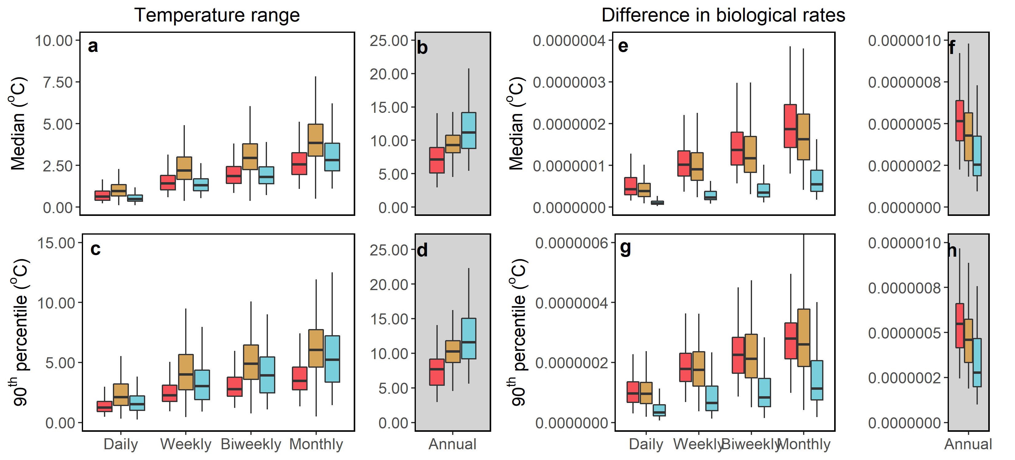

**Supplementary Fig. 1**: Differences in the temperature range (a-d) and range of biological rates (e-h) in temperate (blue), subtropical (yellow) and tropical (red) regions, computed at 5 temporal windows: daily, weekly, biweekly, monthly, and annual. The results shown here used a subset of the data in Figure 3 of the main paper, as a sensitivity test to check the robustness of our results. For each temporal window, the median and 90th percentile were calculated only if the temperature records did not contain more than the following percentage of missing values over the period of the temporal window: i) Daily - 10%, ii) Weekly - 30%, iii) Biweekly - 30%, iv) Monthly - 30%, and v) Annual - 30%. For monthly and annual, there had to be more than 27 days and 330 days in the temporal window respectively.

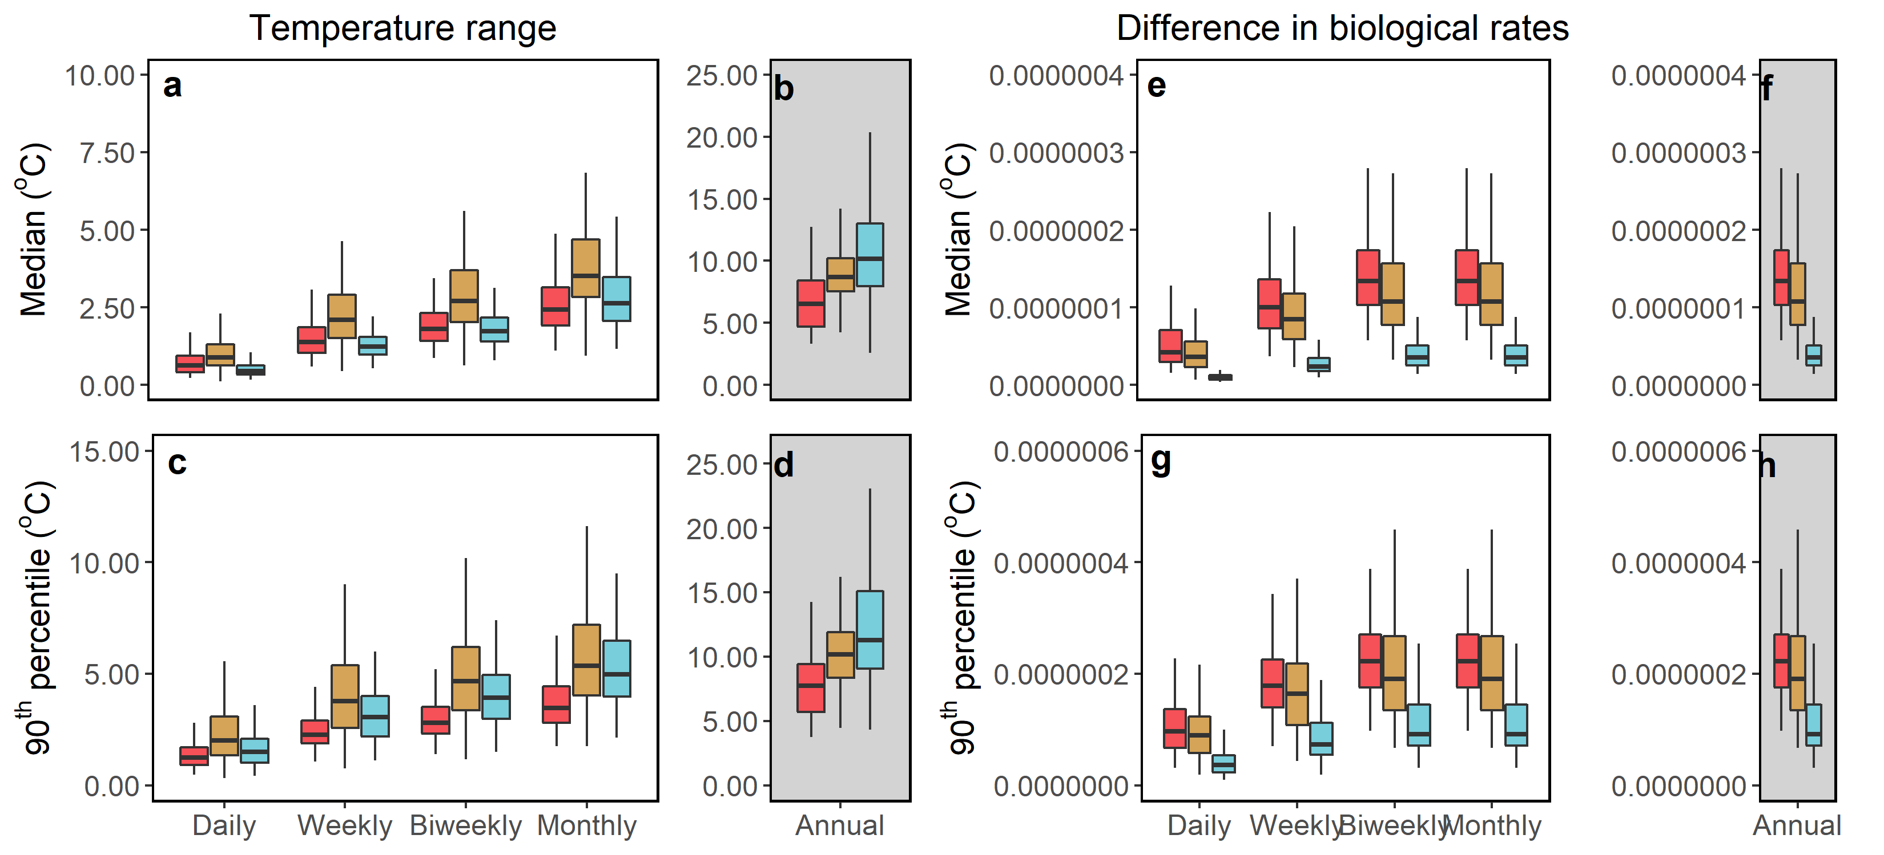

**Supplementary Fig. 2:** Differences in the temperature range (a-d) and range of biological rates (e-h) in temperate (blue), subtropical (yellow) and tropical (red) regions, computed at 5 temporal windows: daily, weekly, biweekly, monthly, and annual. The results shown here used a subset of the data in Figure 3 of the main paper, as a sensitivity test to check the robustness of our results. Time series that were less than 1 year in duration were removed, such that all temporal windows had the same locations being represented.

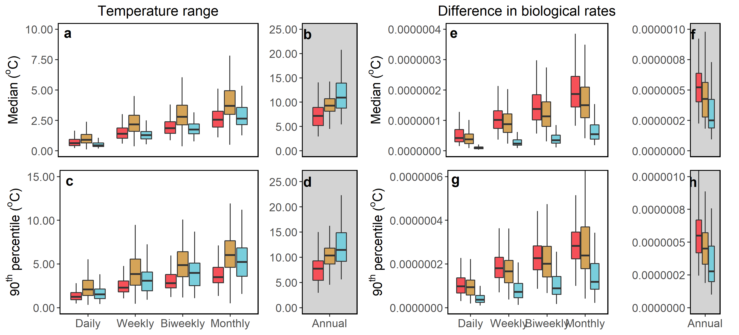

**Supplementary Fig. 3:** Differences in the temperature range (a-d) and range of biological rates (e-h) in temperate (blue), subtropical (yellow) and tropical (red) regions, computed at 5 temporal windows: daily, weekly, biweekly, monthly, and annual. The results shown here used a subset of the data in Figure 3 of the main paper, as a sensitivity test to check the robustness of our results. These results met the criteria of the results in both Supplementary Fig. 2 and Supplementary Fig. 3.